Configuration of DNS server
1 To check the system IP address #ifconfig
2 To install the package for DMS Server #yum install bind* -y
3 To the edit the configuration file #vi /etc/named.conf

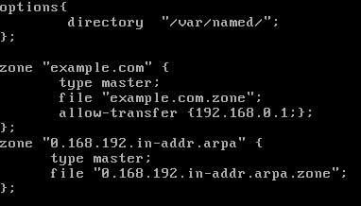
Configure zone file
Change directory to /var/named and copy the sample files to name which we have set in named.conf
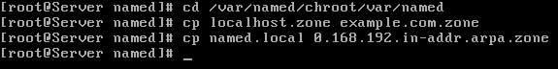
Now open forward zone file example.com.zone
By default this file will look like this
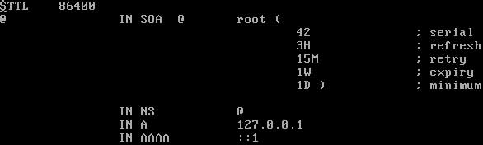
Change this file exactly as shown in image below
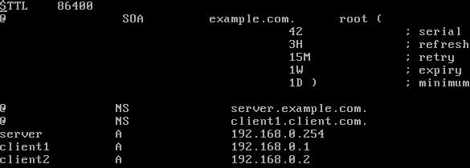
Now open reverse look up zone file 0.168.192.in-addr.arpa
By default this file will look like this
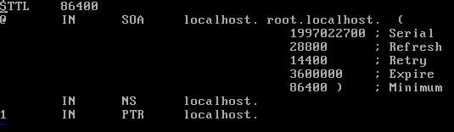
Change this file exactly as shown in image below
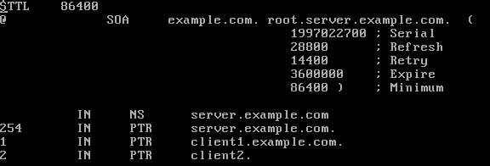
Now start the named service #service named restart

